Inter-VLAN Routing
Inter-VLAN Lab Summary
I created a small lab using Inter-VLAN routing. I configured VLAN 10 on Switch 1 and VLAN 20 on Switch 2. After that, I configured Inter-VLAN routing to enable communication between the two VLANs. I set the ports between the devices and the switches to access mode, and I configured a trunk link between the two switches to allow VLAN traffic to pass through. Then, I assigned IP addresses to the PCs and tested the connectivity using the ping command. The communication was successful.

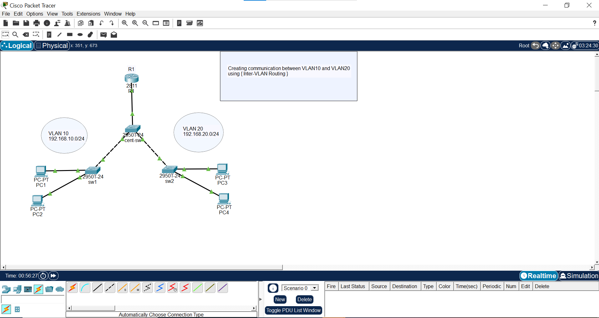
home lab

create vlan 10 on sw1 , vlan 20 sw2

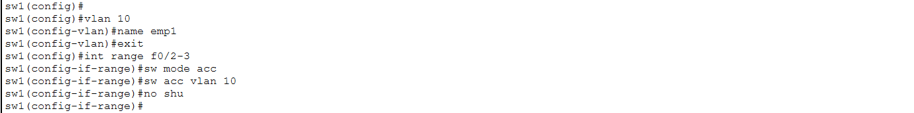
sw1


sw2
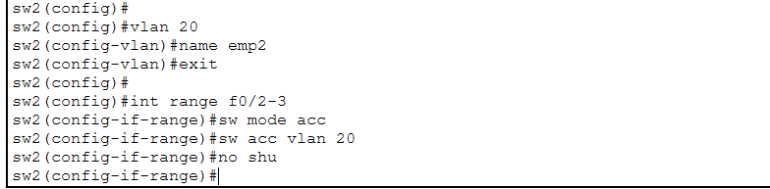


Cental sw
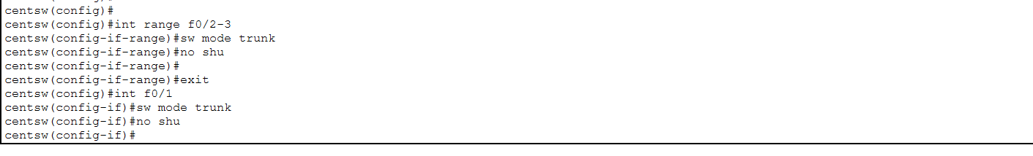


R1 -Inter-VLAN Routing
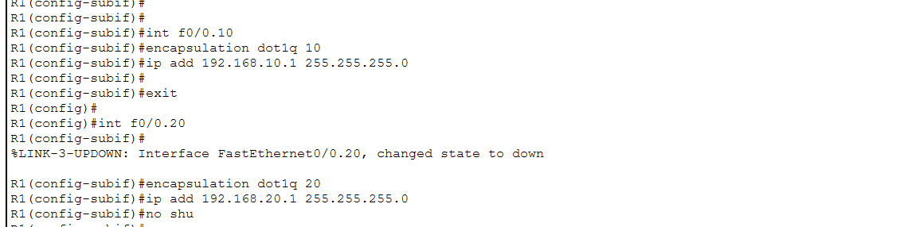

Ping pc1 – pc3
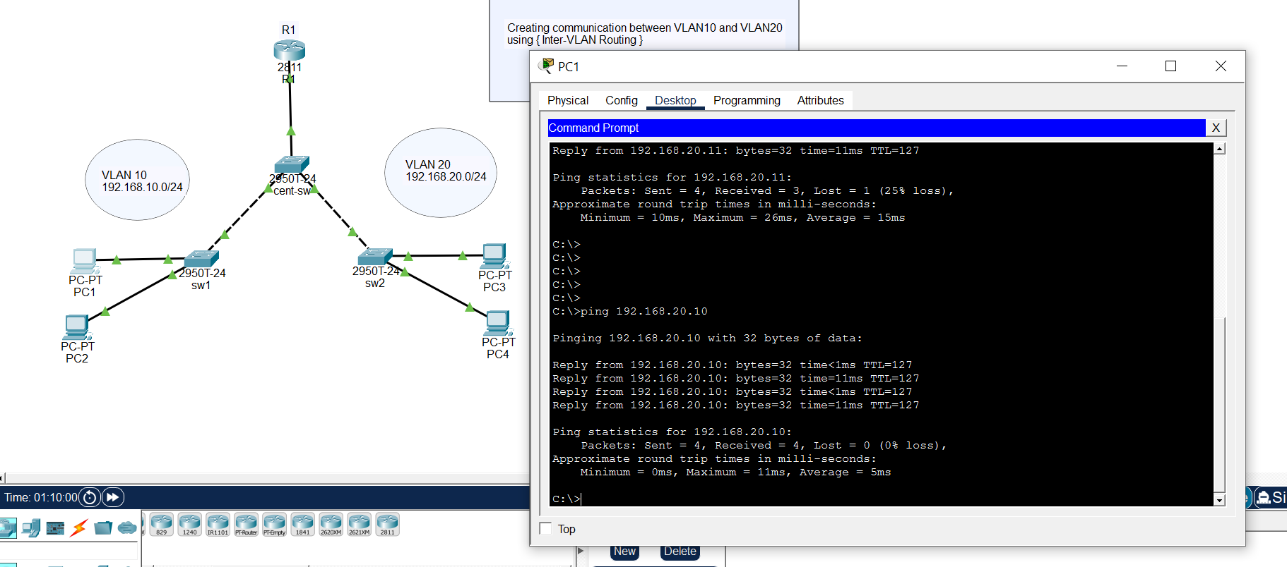

Sara abu-zyoud

